**Assignment -4**

|  |  |
| --- | --- |
| Assignment Date | 09 November 2022 |
| Student Name | Vithya. T |
| Student Roll Number | 211519106181 |
| Maximum Marks | 2 Marks |

**Docker and Kubernetes**

**Question-I:**

**pull an image from docker hub and run it in docker playground.**

**pull an image form docker hub**

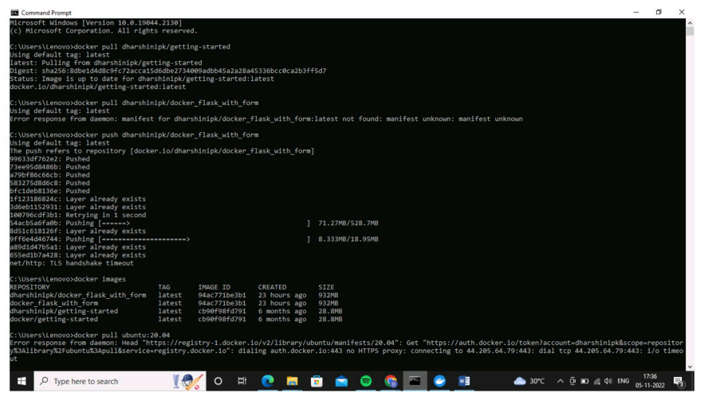

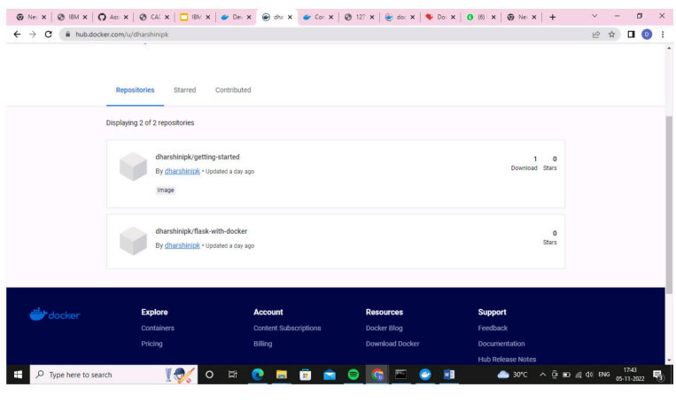

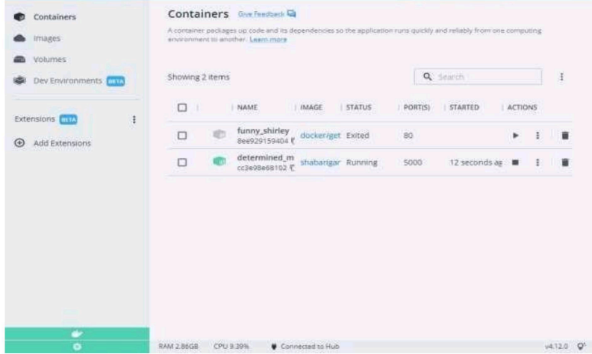

**Question-2:**

**Create a docker file for the job portal application and deploy it in docker application.**

**Creating a docker file for the job portal application**

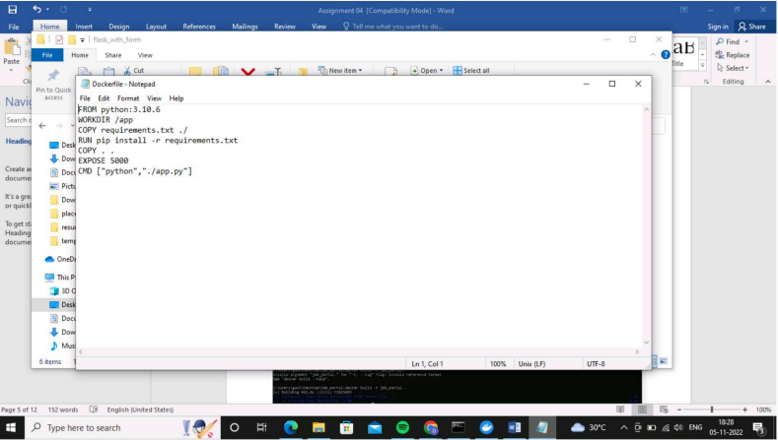**deploy in docker application**

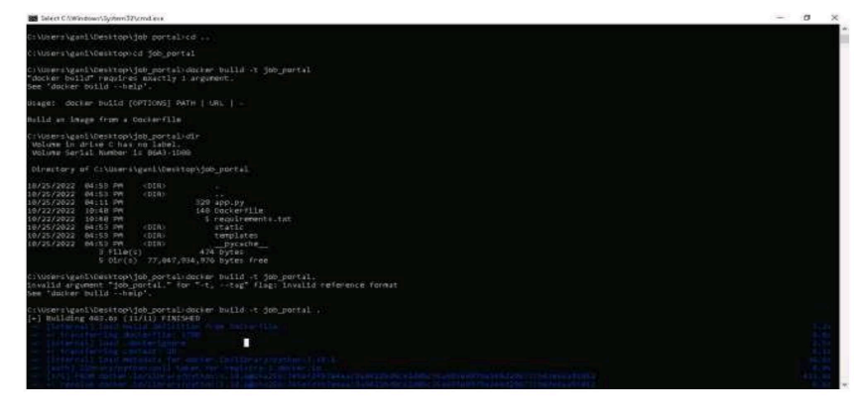

**running in docker desktop**

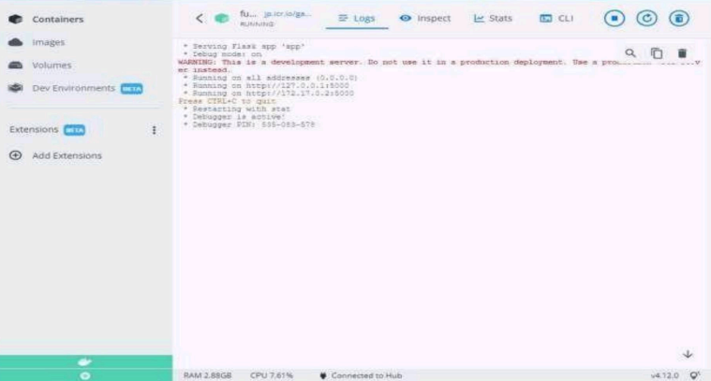

**Question-3:**

**Create a IBMs container registry and deploy hello world app or job portal app**

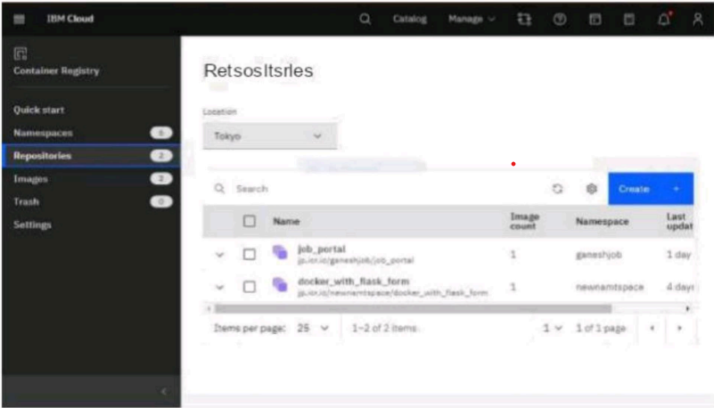

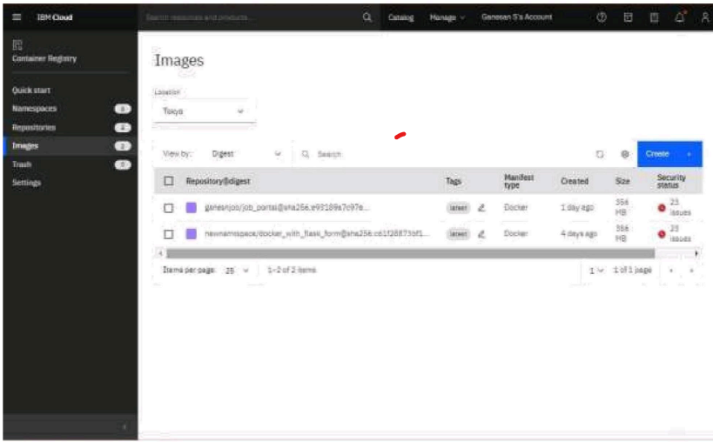

**Deploy hello world or job portal**

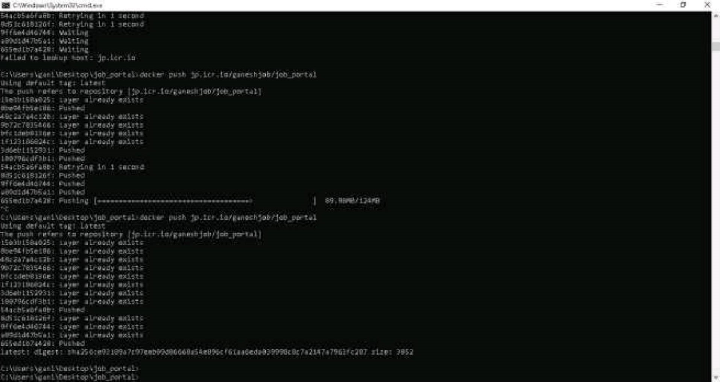

**Question-4:**

**Create a Kubernetes cluster in IBM cloud and deploy hello world image or job portal image and also expose the same app to run in note port**

**Creating a Kubernetes cluster in IBM cloud**

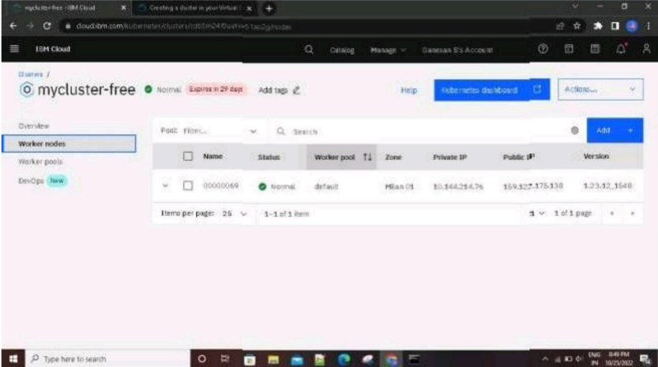

**expose the same app to run in note port**

